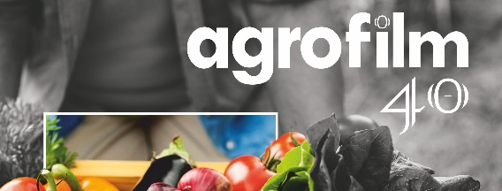
APPLICATION FORM FOR FILM
Deliver with a commentary letter at latest on July 31 2024 to the address:
NPPC, Research Institute for Animal Production Nitra
Hlohovecká 2, 951 41 Lužianky, Slovak republic
phone: +421 37 65 46 126, e-mail: agrofilm@nppc.sk, agrofilm2024@gmail.com
web: www.agrofilm.sk
Title of the film (original):
Title in English:
Country of origin: | Production year:
Producer: Bro
Client:
What audience it is intended for:
Directed by: | Screenplay by:
Director of photography: | Professional advisor:
Web address to download the film:

Screen time (mm:ss):

Password to download the film:
Type of the data carrier (if it is not available for download):

Language:

Annotation (to be published in the catalogue, short description of the film up to 100 words):

Commentary document is enclosed in language:
We agree with a non-commercial post-festival screening for study purposes*:
YES
NO
We agree with online festival screening via link www.agrofilm.sk*:
YES
NO
APPLICANT:
ADDRESS: | E-mail:
TELEPHONE: | Contact person:
We agree with the Statute of AGROFILM 2024 and register this film to the competition
I hereby declare that I have read the conditions for the processing of my personal data contained in the document "Film Festival AGROFILM Privacy Policy" published on the website of the Operator www.agrofilm.sk

date signature, stamp
We request the return of the film submitted on a data carrier*:
YES
NO
to the address: …............................................................................................
*) tick the appropriate box Please fill in all data legibly!

